Assignment 3.1: Collaboratively Assess Cultural Leadership in Your School

Part 1: Assessing Cultural Leadership Data

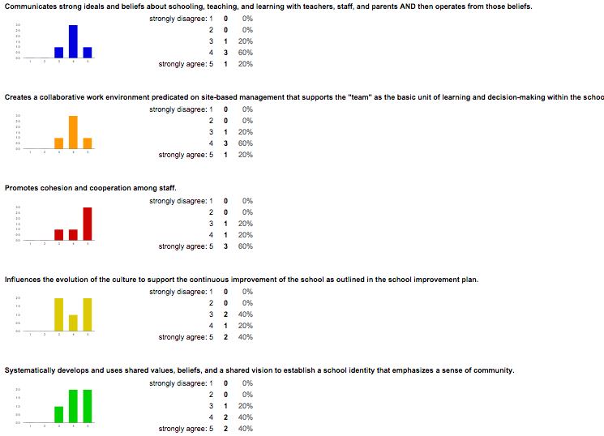
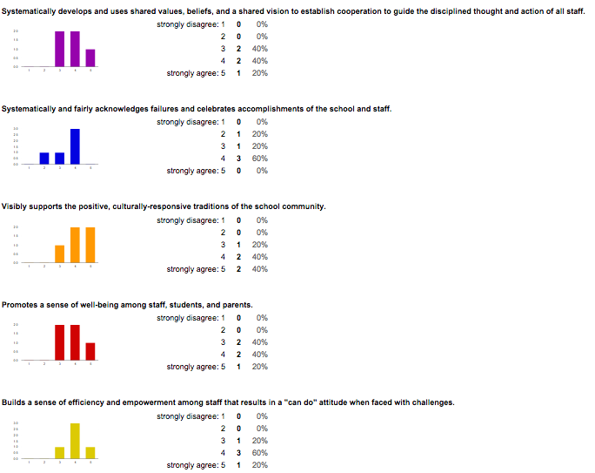

Part 2: Reflection on Cultural Leadership Practices: Areas of focus and next steps

Systematically develops and uses shared values, beliefs, and a shared vision to establish cooperation to guide the disciplined thought and action of all staff. (3.8)

Action Steps:
- Revisit and reflect on vision at staff meeting.
- Revisit and reflect on vision at PLCs.
- Revisit and reflect on vision at SIT meeting.
- Create committee of teacher leaders to seek input on progress made towards fulfilling the vision and need to rewrite vision statement.

Systematically and fairly acknowledges failures and celebrates accomplishments of the school and staff. (3.4)

Action Steps:
- Empower Cougar Spirit Initiative Committee to seek opportunities to celebrate personal and professional accomplishments of all staff members (including funding).
- Administration will be intentional and deliberate in seeking opportunities to celebrate personal and professional accomplishments of all staff members.
- Administration will be sensitive, compassionate, and relevant when acknowledging failures collectively and individually. Additionally, administration will provide relevant systems and supports.
- Continue to build PBIS initiatives to promote positive behaviors and celebrate accomplishments of staff and students.

Promotes a sense of well being among staff, students, and parents. (3.8)

Action Steps:
- Administration will maintain an open-door policy and communicate with honesty, transparency, and compassion.
- Create a social media networking presence to promote positive activities at the school and keep parents, students, and staff in the loop.
- Continue to build PBIS initiatives to promote positive behaviors and celebrate accomplishments of staff and students.
- Share positive stories via local media, social media, weekly communication blogs, etc.
- Create a presence within the community and invite community to the school with various initiatives.

Part 3: Assessing Cultural Leadership Practice Online Survey

Survey Link

Assignment 3.3: Personal Reflection on Cultural Leadership

Cultural Leadership, as one of the four People standards, is essential to improving learning and teaching. Cultural Leadership is a reflection of the leaders values. As we discussed in the last session, you show what you value by how you spend your time. As an educational leader, we must reflect on our actions, how those actions will be perceived, and how those actions align with the vision of the school.

Theodore Roosevelt said, “People don’t care about how much you know until they know how much you care.” This statement sums up Cultural Leadership, as school culture is primarily a reflection of the values and shared vision of the people in the building. Culture is generally collective, however, the leader’s influence can singularly impact that culture. Cultural Leadership is the foundation on which the school sets. The highly successful Jim Goodnight stated, “Our employees are the lifeline of our success. As we enter our 36th year of business, we look forward to continuing our deep investment in employee satisfaction, wellness and creativity.” As school leaders, we must work to build trusting relationships with our staff, students, and supporters. Those relationships alone are not enough. We must also work to build the capacity of others to lead by capitalizing on the unique talents of every individual in our building through distributive leadership practices. We must not only make our stakeholders feel valued as people, but also worthy as professionals. We must focus on creating a culture of productivity and accountability while preserving creativity, collaboration, and joy in the work that is being done. We must be intentional in our efforts to ensure that “how we do business around here,” reflects the core values, mission, and vision of the school and that the practices are efficient, effective, and sustainable.

The North Carolina Standards for School Executives Handbook addresses Cultural Leadership:
School executives will understand and act on the understanding of the important role a school’s culture contributes to the exemplary performance of the school. School executives must support and value the traditions, artifacts, symbols and positive values and norms of the school and community that result in a sense of identity and pride upon which to build a positive future. A school executive must be able to “reculture” the school if needed to align with school’s goals of improving student and adult learning and to infuse the work of the adults and students with passion, meaning and purpose. Cultural leadership implies understanding the school as the people in it each day, how they came to their current state, and how to connect with their traditions in order to move them forward to support the school’s efforts to achieve individual and collective goals.

The school executive practices effective cultural leadership when he or she:
• Creates a collaborative work environment predicated on site-based management that supports the “team” as the basic unit of learning and decision-making within the school and promotes cohesion and cooperation among staff;
• Communicates strong ideals and beliefs about schooling, teaching, and professional learning communities with teachers, staff, parents, and students and then operates from those beliefs;
• Influences the evolution of the culture to support the continuous improvement of the school as outlined in the School Improvement Plan; North Carolina Standards for School Executives
• Systematically develops and uses shared values, beliefs and a shared vision to establish a school identity that emphasizes a sense of community and cooperation to guide the disciplined thought and action of all staff and students;
• Systematically and fairly acknowledges failures and celebrates accomplishments of the school and staff;
• Visibly supports the positive, culturally responsive traditions of the school community;
• Promotes a sense of well being among staff, students and parents;
• Builds a sense of efficacy and empowerment among staff that result in a “can do” attitude when faced with challenges; and
• Empowers staff to recommend creative, 21st century concepts for school improvement.

